

Life Skills LFS104 Having a Drink

Only for mixer drinks

Imagine if you fancy a mixer drink but don’t want to get drunk or let your friends get drunk?

Here is a little trick that will save you money stop you from becoming paralytic and let you enjoy a nice drink?



Put on one side an Ice bucket, Coke or Soda or other mixers and follow these instructions…

First get several large glasses and half fill them with your favourite drink, Scotch, Vodka, Gin etc. Put them in the kitchen out of the way…

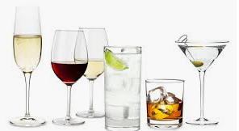


Get a smaller glass and invert it so that it sits in the spirit glass

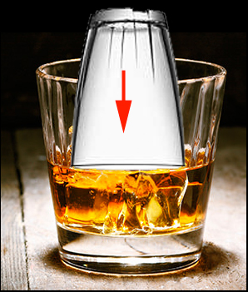 or 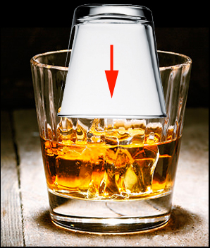

The glass will take up the scotch on the rim, take out the glass add ice, lemon and mixer and give it to your friend or yourself.

The first thing you will taste is the spirit then the mixer so you think you are getting a nice drink.

But in effect you are simply getting a sample drink and after the first taste you will assume you have a normal drink.

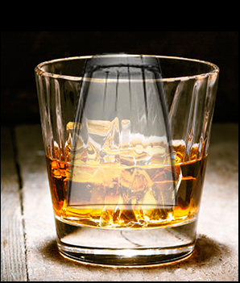

After a few drinks you will be enjoying yourself but not getting drunk.

Try it!

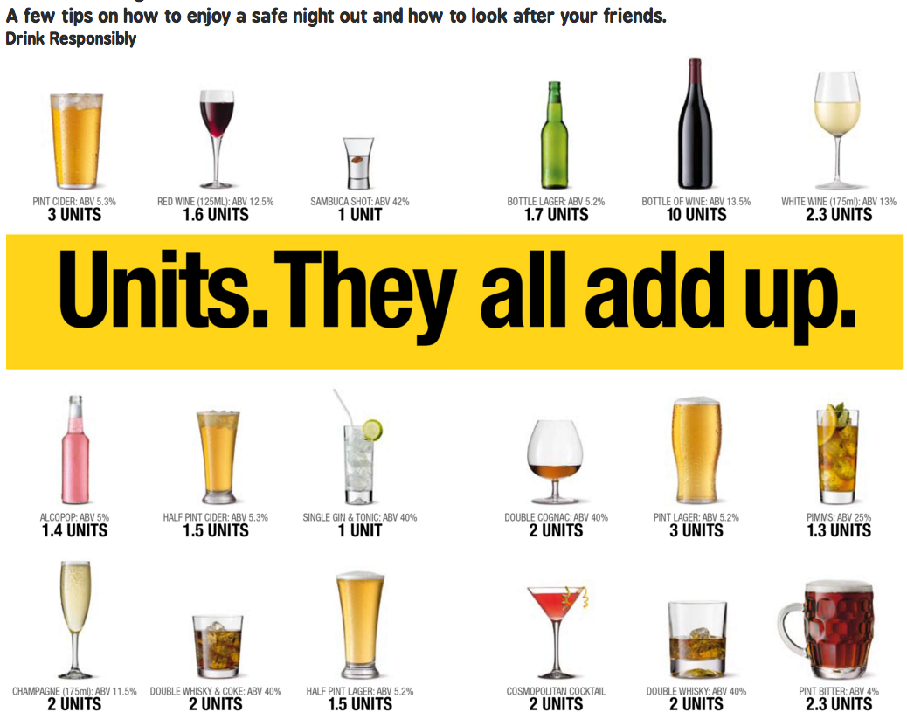

As students we found this trick very effective for saving us money and looking after our friends it was amazing how the night went of brilliantly but everyone got home safe. Drink responsibly

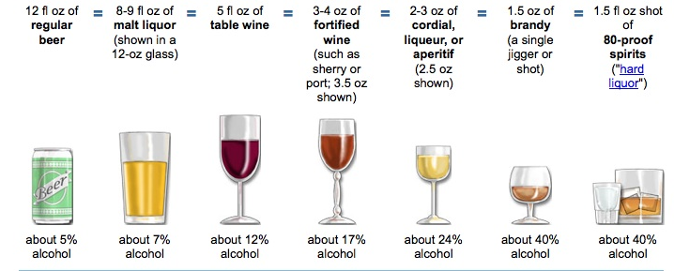

The core Life Skills as laid down by WHO are:

There are many such skills, but core life skills include the ability to:
- Self-awareness.
- Empathy.
- Critical thinking.
- Creative thinking.
- Decision making.
- Problem Solving.
- Effective communication.
- Interpersonal relationship.

The Ten core Life Skills as laid down by you (add your own)

Think and learn to think, think when you speak, and think when you do anything.
Learn to perform good in your world, be professional in everything that you do.
Wherever you go never forget your parents or friends. Call them often and stay connected, tell someone where you are going.
Take the opportunity and travel as much as you can whether for work or for fun, life's experiences come from seeing and meeting interesting people and visiting new places.
Learn to cook enough to feed your self, start with easy things then try more interesting menus.
Read and learn from others experiences and learn more, read a good range of books and have a joke book as your table book to brighten up your day.
(https://www.penguin.com.au/books/man-walks-into-a-bar-9781446406427)
Learn to be responsible for yourself look after your belongings and especially your health everything depends on you and you only.
Learn to enjoy everything that you do if you fail at least you tried, but learn from your failings, learn fail then learn again.
Learn to ignore the small things and concentrate on the big picture, you will be much happier if you don't let trivialities get you down.

Smile look in a mirror and smile and stay positive and happy.

